|  |  |
| --- | --- |
|  | INSTITUTE OF TECHNOLOGY BLANCHARDSTOWN |

**B.Sc. in Computing in Information Technology**

**BN302, BN013, BN104**

**Group Project Ideas**

**2009 - 2010**

1. **Arnold Hensman**

**1.1** **Online Study Group System**

**Project Description**

Development of a web based system for users to register and sign on in order to schedule, conduct and manage an online study group. Incorporation of Open Source Moodle object, ‘DimDim’ to facilitate the meeting system.

**Technologies Involved**

PHP, XHTML, MySql, ServerConnection, Moodle, DimDim Open Source. Or other scripting Language of student’s choice.

**1.2 Supermarket Pricewatch Website**

**Project Description**

With the current disparity in the price of items throughout the various supermarkets, a gap exists for the development of a web based system that allows users to enter and update the current prices of items in different supermarkets. The system will manage which shop offers the most competitive price at any time as well as other statistics to aid shoppers in their choices. Similar idea to Twitter.com but this site would focus as a pricewatch on local areas. E.g. Supermarkets in Dublin 15.

**Technologies Involved**

PHP, XHTML, MySql, ServerConnection, Or other scripting Language of student’s choice.

**1.3 *Cartoonify Me***

**Project Description**

Many Tools exist that allow the user to draw up a cartoon version of themselves for an avatar, but few if any do this well in an automated fashion.

The student would use simple computer vision and image processing techniques to automatically make a call on how a photo of someone should be converted to its equivalent cartoon image. Useful for avatars/ Wii consoles etc.

Ideally the systems would access a webcam that would take a photo os a user and automatically create the cartoon avatar that may be tweaked later.

This tool could also be web enabled for further application.

**Technologies Involved**

Image processing algorithms. C/C++ or Java.

Creation of a DLL for use within the application. Incorporation of a peripheral device such as a web cam, mobile phone or PDA hand held device.

Database for image storage.

Web enabled version of the same.

**1.4 Facial Recognition Tool**

**Project Description**

A system should be developed which can analyse and compare a digital photo of someone’s face for identification purposes to a dataset of other samples.

Image analysis project including manipulation of image as a 2 dimensional array of pixels. A stand alone tool with a strong graphical user interface will be developed to facilitate ease of use for a general audience.

**Technologies Involved**

Image processing algorithms. C/C++ or Java.

Creation of a DLL for use within the application. Incorporation of a peripheral device such as a web cam, mobile phone or PDA hand held device. Database.

**1.5 Data Compression Tool**

**Project Description**

Analysis of Data Compression techniques and production of an application to perform each of these with a comparative analysis using the appropriate data structure and test results.

Similar to WinZip, the application should be graphical and easy to understand. Implementation of the appropriate data structures will be involved along with a usable Windows based interface.

**Technologies Involved**

Basic data compression techniques implemented in Java/ C/C++.

Development of User interface

**1.6 Online Tax payment system.**

**Project Description**

Initial evaluation of Irish general taxation sites such as motor tax and bin charges.

The student will thus create an integrated site to simulate payment of these taxes and management of customers from a single source. The project will require strong analysis and design techniques to improve on the many reported inadequacies of online taxation websites.

**Technologies Involved**

Web development three tiered model to create an interactive and secure site for payments.

1. **Luke Raeside**

**2.1 Web-based Internationalized E-mail Calendar/Organiser**

**Project Description**

Create a Web-based Calendar/Organiser so that users can receive automatic e-mail (and/or text) reminders about important dates and events which will occur. The system must allow users to register with their details and will subsequently store the individual users' calendar information. The system should also provide for internationalization of the system so that users from different countries can user the site (English, French, Spanish, for example).

**Technologies**

Databases, Java, JSP, UML

**2.2 Web-based Collaborative E-Science related journal entry system**

**Project Description**

Create a collaborative e-Science journal entry system for schoolchildren carrying out science projects. This system aims to support journal entries from groups of schoolchildren attempting to complete a collaborative science project. The system must be capable of registering the students’ names and details and then forming the students into groups and projects. The system will then permit students’ part-taking in a science project to make journal entries that are time-stamped for the duration of a project.

**Technologies**

Java, JSP, Databases, UML

**2.3 Web-based Image analysis software for Astronomy studies**

**Project Description**

Create a Web-based system for the analysis of Astronomical images. The system should be capable of loading a variety images and enable students to make basic image-based calculations. The system must be capable of storing the data collected in XML format into a database.

**Technologies**

Java, JSP, Databases, XML, UML

**2.4 Web-based XML spreadsheet and graph generator**

**Project Description**

Create a Web-based XML spreadsheet and graph generator. The system should allow the user to enter spreadsheet data (numerical data) into a Web-based spreadsheet system. The system must then store that data entered into XML format. The system will also be capable of reading this data and producing a variety of image-based graphs to represent the data visually.

**Technologies**

Java, JSP, Databases, XML, UML

1. **Mark Cummins**

**3.1 Website Log Analyser**

**Project Description**

Every request made to a web server is logged to a file. A log analyser is a program that compiles statistics using these log files and creates a report with it. Usual statistics compiled by a log analyser are hits and visits count, bandwidth usage, daily/weekly/monthly activity, file access, visitors' referrer, search phrases and search engines, HTTP errors etc.

There are a number of commercially available log analysers available for each of the main web server log formats. Your project would be to produce an open source log analyser capable of producing graphical reports.

Analysing W3C Extended format (Apache) and IIS format could be pre-defined in the program, but it should be possible to support virtually any log format by allowing the user to define the parsing model themselves.

**Technologies**

Any modern programming language would be capable of processing the raw data from the log files and generating reports. A web based frontend would seem the obvious choice and the use of XML would greatly add to the project.

**Extras**

Making the project open source compliant could be a large extra component to the project.

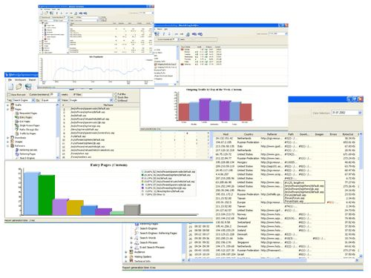

* 1. **Interactive Tabletop Application**

**Project Description**

Recent work by researcher Johnny Lee has shown several uses for the Nintendo Wii remotes. I’ve deployed all of his demos and samples, but there are many more possible projects leading from these. One idea would be to create a cheap multi-touch worktop and an associated application. I’m suggesting a multi-touch CAD interface that could be used by large architectural and design firms. These products commercially can cost upwards or €200,000.

**Technologies**

Unfortunately most of the existing work has been done in C/C++ but there are also a few options using java. This project will involve interfacing using Bluetooth and possibility some basic electronics.

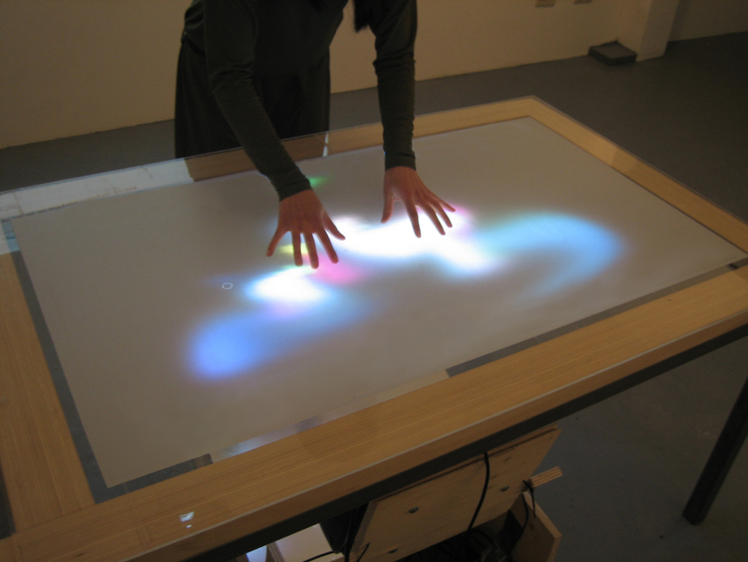

**3.3 Iphone wireless network monitoring tool**

**Project Description**

Deploying wireless networks can be tricky. Obstacles such as hills and buildings affect the signal strength differently at different locations, making it difficult to pick locations for access points that offer the maximum coverage. With the increased availability of location (GPS) data and wifi finders hardware included on modern phones, PDA and laptops, it should be possible to produce a software tool for network planners/administrators to allow them map the signal strength of their wireless networks much cheaper using existing hardware and without the need for expensive hardware tools.

**Technologies**

Will depend on platform, PDA, Phone or Laptop. Likely be a combination of existing protocols and varies languages.

**Extras**

I would like to see this as an iPhone application but other extras could be added to the tool, such as automatically checking security and network latency.

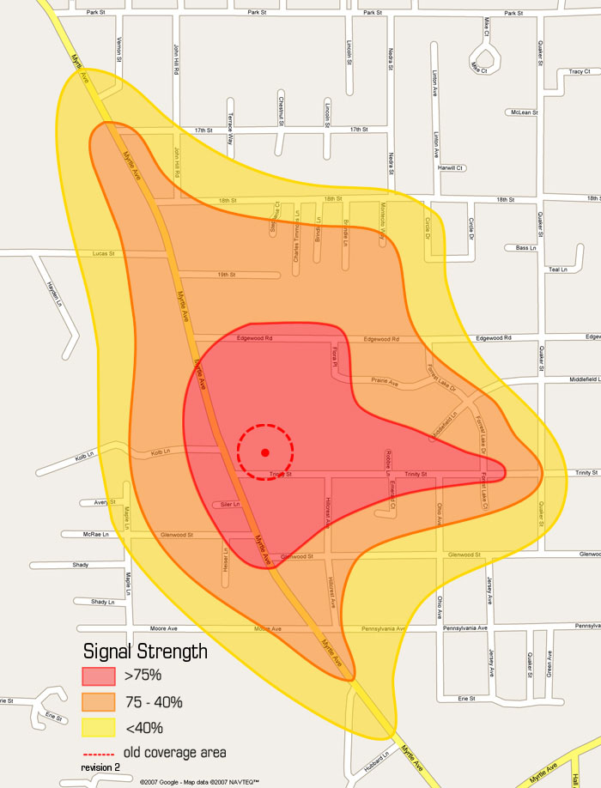

**3.4 IPhone Application (student proposal)**

**Project Description**

Apple’s iPhone popularity has been mainly contributed to its application store, offering thousands of both free and paid applications for download to add to the functionality of the user’s phone. Any students wishing to try develop any particular application for the iPhone, I’ll gladly supervise and support and even recommend a few applications, depending on the students own level and abilities.

**Technologies**

Apple iPhone developer kit

**Extras**

Publish to iPhone app store!

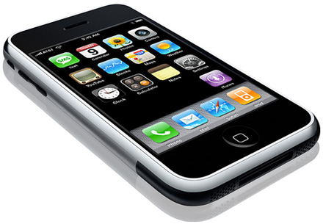

1. **Kevin Farrell**

# 4.1 Modelling and Visualising Vehicular Traffic: Testing Braes’ Paradox

**Project Description**

Modelling of vehicular traffic (cars, HGVs, buses, etc.) has become an integral part of modern land-use and transport planning. So-called micro-simulation methods, which model individual travellers in a road network, have been used for many years for junction analysis. Many of these methods are implemented using Cellular Automata (CA). Due to increases in computer performance, and due to the availability of cheap High Performance Computing clusters, micro-simulation models are now becoming more widespread for use in city-wide models also. These types of model have important consequences for decision-making, as they are able to demonstrate that intuitive decisions by Traffic Engineers are not always the correct one! One such scenario is that described by Braes’ Paradox.

The aims of this project are to:

* develop a simple micro-simulation model of traffic flow
* write an application to visualise that traffic flow, showing locations of congestion and free-flow
* test Braes’ Paradox using the model

## Technologies

* Cellular Automata
* Java programming
* Simple traffic theory
* Parallel Programming (optional)

**Hardware Involved**

Standard PC is sufficient.

HPC Cluster (if doing parallel programming)

# Medical Appointments Management System

**Project Description**

Nowadays, most medical (GP) practices do not employ sophisticated techniques for assigning appointments. Also, in hospital outpatients departments, it is normal for several patients to be given the same appointment time. Often, this results in significant queues forming in the waiting room, posing a health-risk to vulnerable patients, whilst inconveniencing others.

The aim of this project is to develop a *platform-independent*, open source software system to enable a medical practice to predict accurate appointment times. This will allow it to fill its appointment book in an efficient manner providing a better level of service to clients.

The system will, at minimum, consist of the following components:

1. A GUI front-end for use by a Receptionist, incorporating:

* Data Entry: Typical type of data: Did the patient arrive/not arrive (DNA), Arrival time of patient, appointment time, actual time seen by Doctor, time finished with Doctor, time of year, nature of complaint etc.
* Outputs: Prediction of best Appointment time, Statistical Reports and Charts.

1. A database-backend for secure storage of the information, and for easy retrieval.
2. A queuing algorithm for calculating appointment times based on collected data.

**Technologies**

1. Linux OS and M$ Windows XP
2. MySQL databases
3. Apache Webserver
4. Java, Javascript or PHP
5. Queuing Theory

## Other Requirements

Site visit to, and liaison with, one or more GP practices. (Some initial contacts have already been made).

1. **Anthony Keane**

**1.1 Mobile Devices**

1. Laptop encryption will be made mandatory at many government agencies and other organizations that store customer/patient data and will be preinstalled on new equipment. Senior executives, concerned about potential public ridicule, will demand that sensitive mobile data be protected

2. Theft of PDA smart phones will grow significantly. Both the value of the devices for resale and their content will draw large numbers of thieves.

3. Governments will pass more legislation governing the protection of customer information. If USA Congress, as expected, reduces the state-imposed data breach notification requirements significantly, state attorneys general and state legislatures will find ways to enact harsh penalties for organizations that lose sensitive personal information.

**1.2 Attack Targets**

4. Targeted attacks will be more prevalent, in particular on government agencies. Targeted cyber attacks by nation states against US government systems over the past three years have been enormously successful, demonstrating the failure of federal cyber security activities. Other antagonistic nations and terrorist groups, aware of the vulnerabilities, will radically expand the number of attacks. Targeted attacks on commercial organizations will target military contractors and businesses with valuable customer information.

5. Cell phone worms will infect at least 100,000 phones, jumping from phone to phone over wireless data networks. Cell phones are becoming more powerful with full-featured operating systems and readily available software development environments. That makes them fertile territory for attackers fuelled by cell-phone adware profitability.

6. Voice over IP (VoIP) systems will be the target of cyber attacks. VoIP technology was deployed hastily without fully understanding security.

**1.3 Attack Techniques**

7. Spyware will continue to be a huge and growing issue. The spyware developers can make money so many ways that development and distribution centres will be developed throughout the developed and developing world.

8. 0-day vulnerabilities will result in major outbreaks resulting in many thousands of PCs being infected worldwide. Security vulnerability researchers often exploit the holes they discover before they sell them to vendors or vulnerability buyers like TippingPoint.

9. The majority of bots will be bundled with rootkits. The rootkits will change the operating system to hide the attack’s presence and make uninstalling the malware almost impossible without reinstalling a clean operating system.

**1.4 Defensive Strategies**

10. Network Access Control will become common and will grow in sophistication. As defending laptops becomes increasingly difficult, large organizations will try to protect their internal networks and users by testing computers that want to connect to the internal network. Tests will grow from today’s simple configuration checks and virus signature validation to deeper analysis searching for traces of malicious code.

1. **Michael O’Donnell**
   1. **Network Simulation using OPNET**

OPNET is a software solution for managing networks and applications. OPNET can create, design and implement scenarios in application troubleshooting, application monitoring, network monitoring, network configuration management, capacity management and network simulation. OPNET software can simulate a wide variety of different networks, which are linked to each other through routers and switches.

There are many possible projects that could be implemented successfully using OPNET. You could use the following ideas as starting points:

* + TCP vs. UDP: influence of different transport protocols on application and network performance
  + TCP Flow Control: influence of window size, MTU, and other parameters on application and network performance
  + TCP Throughput: influence of window size, MTU, and other parameters on application and network performance
  + QoS: Impact of Queuing Policy: influence of different queuing mechanisms on delay, jitter, and traffic loss
  + Comparing a Flat IP addressing scheme with a Hierarchical scheme in Network Design
  + Wireless Network Design

**6.2 Intrusion Detection Systems**

Intrusion Detection Systems such as SNORT or the Cisco 4215 IDS can be used to monitor networks and to block unwarranted intrusions. There is scope here to investigate the effectiveness of such systems and to customise them to meet new attack patterns from the outside.

One solution is the deployment of Virtual Honeynets using VMWare which has the advantage of running all the systems on a single system.

The student can design and implement a Virtual Honeypot/Honeypot system and customise IDS signatures to protect the network from malware intrusions.

* 1. **Online Music Store**

**Project Description**

Plan and design an Online Music store that allows visitors register with the application, search for music items by song, album or artist or on multiple combinations of these keywords and view the latest releases and chart toppers. The application will have an administrator’s page that will allow the administrator maintain user details and manage the music items in the inventory.

**Technologies**

JSP, JDBC, Tomcat/Resin, MySQL

* 1. **Online Banking**

**Project Description**

Your system should aim to incorporate the following services into the functionality of a banking application.

Three key types of services will initially be offered:

* Inquiry Services: These include Balance Updates, viewing lists of transactions and downloading past account history.
* Bill Payment Services: Users will be able to pay bills electronically
* Transaction Services: These include facilities such as money transfers.

A separate mechanism will be requires for administrative functions. The administrator should be able to create new accounts, close accounts, enable online banking for a given customer and cancel bill payment transactions at the account holder’s request.

**Technologies**

JSP, JDBC, Tomcat/Resin and SSL

* 1. **SNMP Monitoring Tool**

**Project Description**

Design and implement an SNMP (Simple Network Monitoring Protocol) Monitoring Tool that allows a network manager to view network status information of say a router from a remote location. The manager should be able to monitor the status of connected interfaces, the IP configuration, the bandwidth usage, routing tables, etc.

Access should be password-protected.

**Technologies used:** Java SNMP and database design.